Tests

This file includes:
- Important tests
- Example Photo
- Variables
- Type of each variable
- Obligatory State
- Cause of this test
- UI name

Blood Group Test:

Variables: ABO_Group , RH_Factor
- Type: String,String
- Obligatory
- Cause: To detect the risk of RH factor

CBC:
Variables: HB, RBCs_Count, MCV, MCH, MCHC, WBC, lymphocytes, platelet_count
Type: float for all
- Obligatory
- Cause: To have a whole look in the Women's Case

IN UI: HB(Hemoglobin), RBC (Red Blood Cells)

HbA1c:

Variables: HbA1c:
Type: Float
- Obligatory
- Cause: To check if the woman has diabetes or not.
- UI: Glucose (HbA1c) test.

Urinalysis
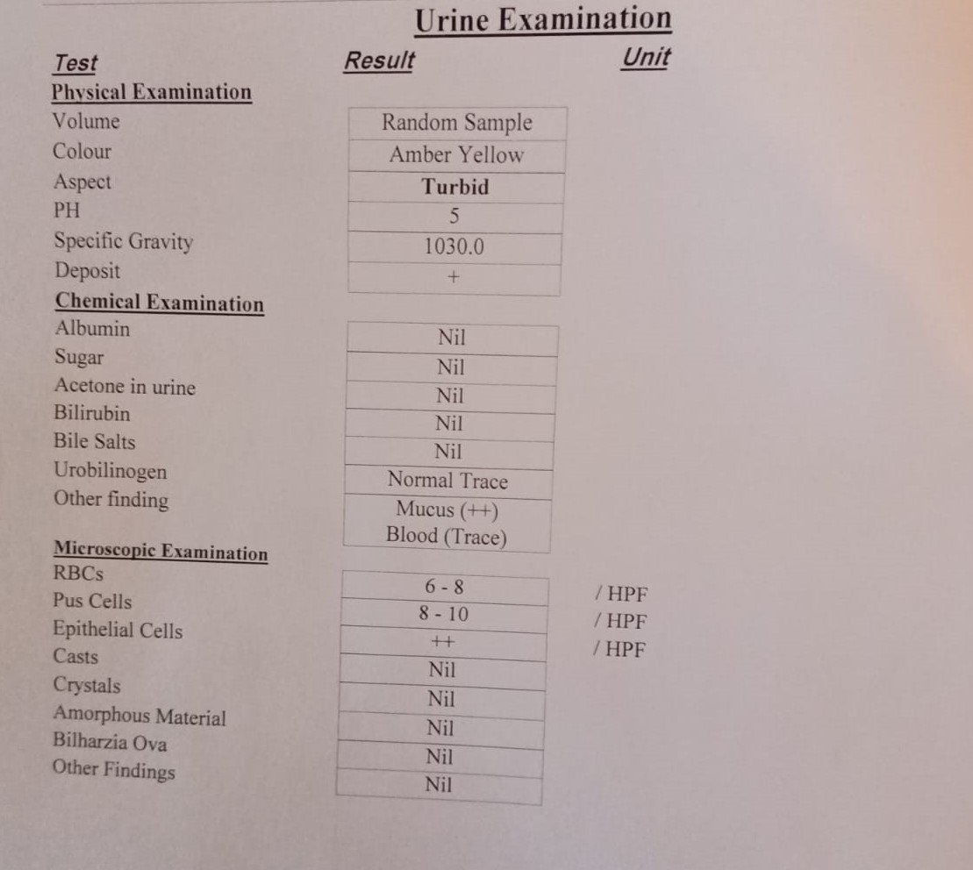
Variables: Color, PH, Specific_Gravity, Protein, Glucose, Nitrite, Ketones, Blood, RBCs, Leukocytes
Types: all : string except , PH /Specific gravity: float ,
- Obligatory
- Cause: early detection of kidney disease
- UI: Urine Test (Urinalysis)
IN UI: Protein(Albumin) , Glucose(Sugar),Ketones(acetone)
Leukocytes(Pus Cells),RBCs (Red Blood Cells)

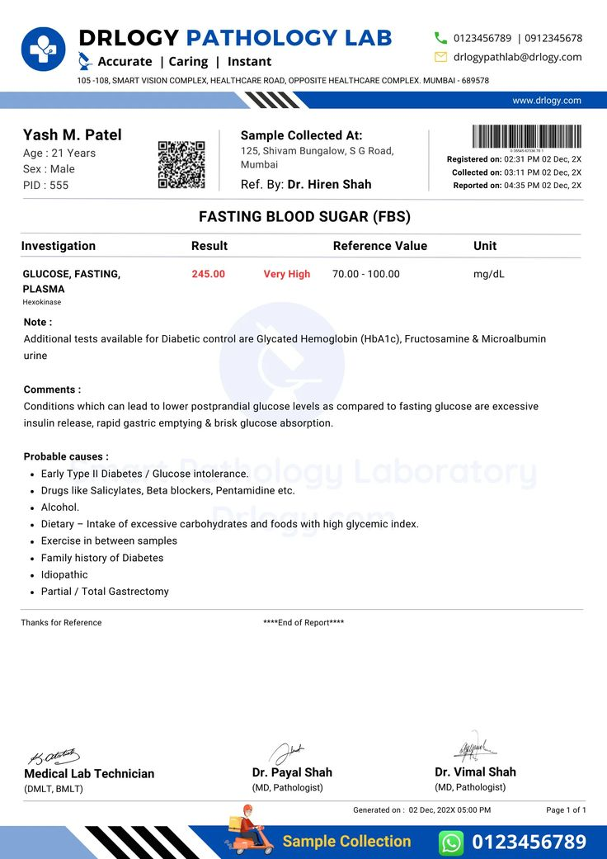
Fasting Blood Glucose:

Variables: FBG
Type: Float
UI: Fasting Blood Glucose
Cause: Diagnose GDM

HBsAg:

Variables: HBsAg
Type : String
- Obligatory
- Cause: To know if the baby has a dangerous virus B
- UI: Hepatitis B test

HCV:
Variables: HCV
Type: String
- Obligatory
- Cause: To know if the baby has a dangerous virus C
- UI: Hepatitis C test

TSH:
Variables: TSH,TSH_Unit
Type: Float,string
- Obligatory
- Cause: Thyroid check/hormone check

Ferritin Levels:

Variables: Ferritin_value
Type: Float
- Optional
- Cause: Need for early prediction of iron deficiency
- Name in UI: Iron/Ferritin Test

For Unextracted data:
Float Data -> -1
String Data -> “Not Extracted”

